LUPINARE
Photographs, 300dpi

Contact:
Kat Kneevers
Kneeverland Productions
414-218-3909
lupinaremusic@gmail.com

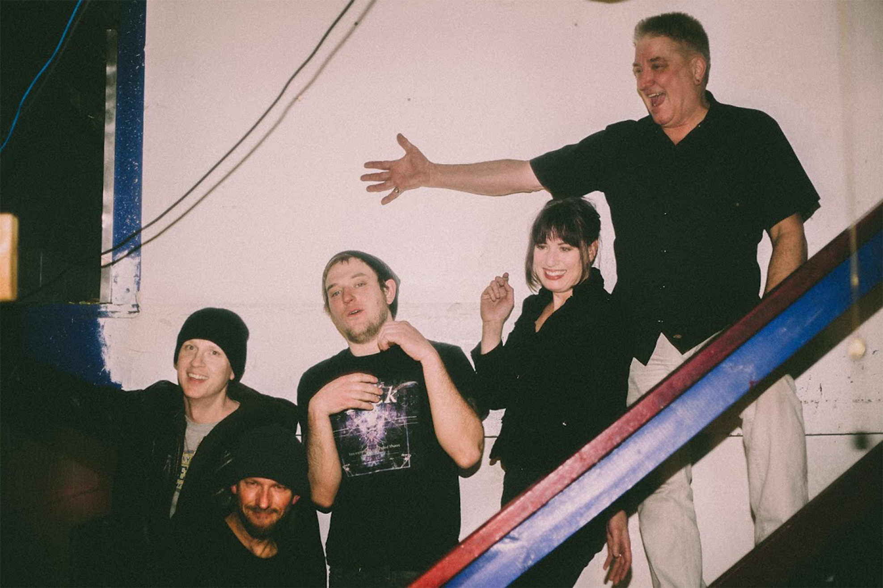
L to R: Dave Stachlewicz, Eric Olsen, Joe Sanfelippo, Kat Kneevers, Paul Kneevers. Copyright 2018 Lupinare.

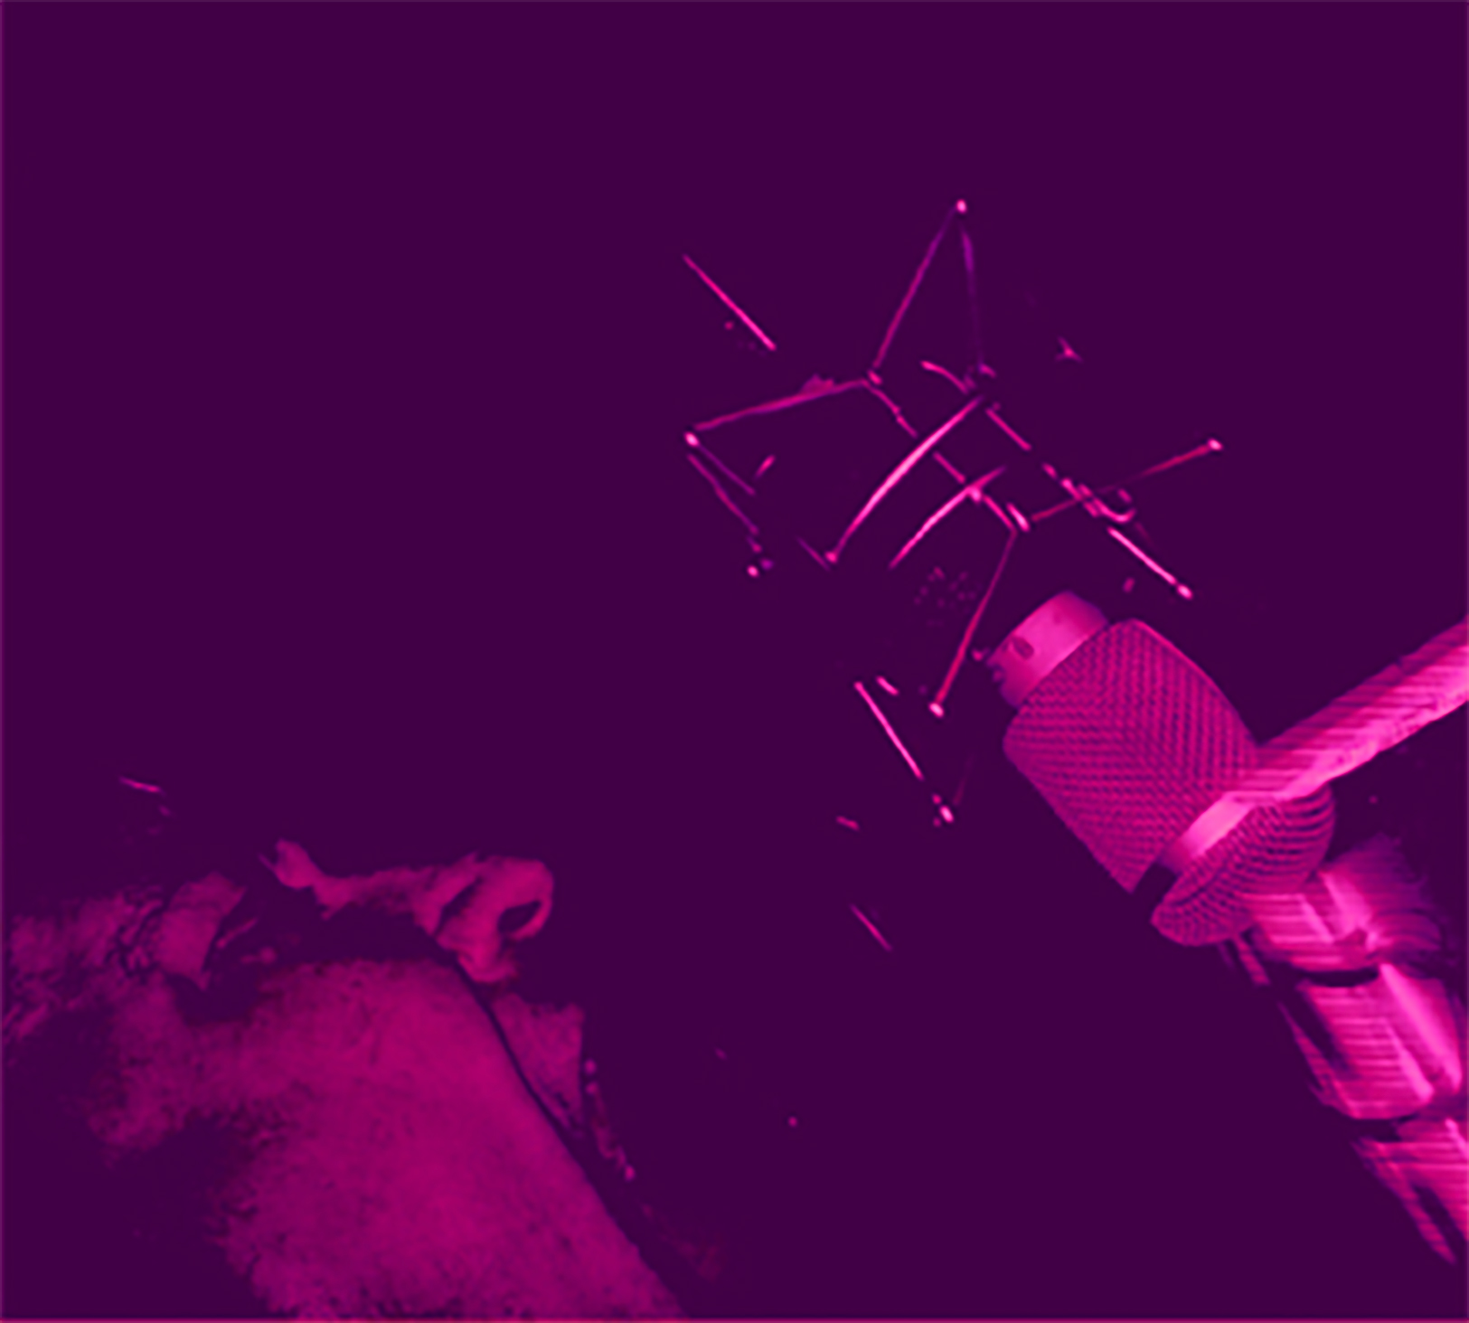
Lupinare’s Paul Kneevers in studio. Copyright 2018 Lupinare.

Lupinare, Involuntary Exposure, released October 26, 2019. Copyright 2019 Lupinare.

